**Multiple Correlation and Regression**

In Multiple Correlation and Regression. When there are two or more than two independent variables, the analysis concerning relationship is known as multiple correlation and the equation describing such relationship as the multiple regression equation. We here explain multiple correlation and regression taking only two independent variables and one dependent variable (Convenient computer programs exist for dealing with a great number of variables). In this situation the results are interpreted as shown below:  
Multiple regression equation assumes the form

**Multiple correlation and Regression**

where X1 and X2 are two independent variables and Y being the dependent variable, and the constants a, b1 and b2 can be solved by solving the following three normal equations:

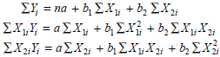

(It may be noted that the number of normal equations would depend upon the number of independent variables. If there are 2 independent variables, then 3 equations, if there are 3 independent variables then 4 equations and so on, are used.)

In multiple regression analysis, the regression coefficients (viz., b1 b2) become less reliable as the degree of correlation between the independent variables (viz., X1, X2) increases. If there is a high degree of correlation between independent variables, we have a problem of what is commonly described as the problem of multicollinearity. In such a situation we should use only one set of the independent variable to make our estimate. In fact, adding a second variable, say X2, that is correlated with the first variable, say X1, distorts the values of the regression coefficients. Nevertheless, the prediction for the dependent variable can be made even when multicollinearity is present, but in such a situation enough care should be taken in selecting the independent variables to estimate a dependent variable so as to ensure that multi-collinearity is reduced to the minimum. With more than one independent variable, we may make a difference between the collective effect of the two independent variables and the individual effect of each of them taken separately. The collective effect is given by the coefficient of multiple correlation,

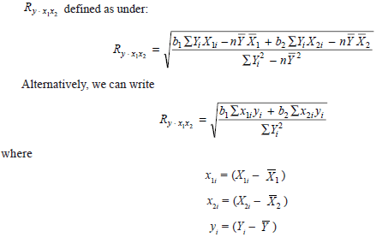

and b1 and b2 are the regression coefficients.